


INDIVIDUAL ASSIGNMENT

LANKA

COMP40004

WEB DEVELOPMENT AND OPERATING SYSTEMS-1
COM2421, COM2422, COM2423, COM2424

HAND OUT DATE: 18th March 2024

HAND IN DATE: ASSIGNMENT2: 20th May 2024

WEIGHTAGE: ASSIGNMENT 2: 30%

INSTRUCTION TO CANDIDATES:

- Students are advised to underpin their answers with the use of references (cited using the Harvard Name System of Referencing).

- Late submission will be awarded zero (0) unless Extenuating Circumstances (EC) are upheld.

- Cases of plagiarism will be penalized

- Assignment presentation should be submitted in the form of softcopy and hardcopy both; modeling work should be submitted in softcopy form

Dairy Page - Mobile
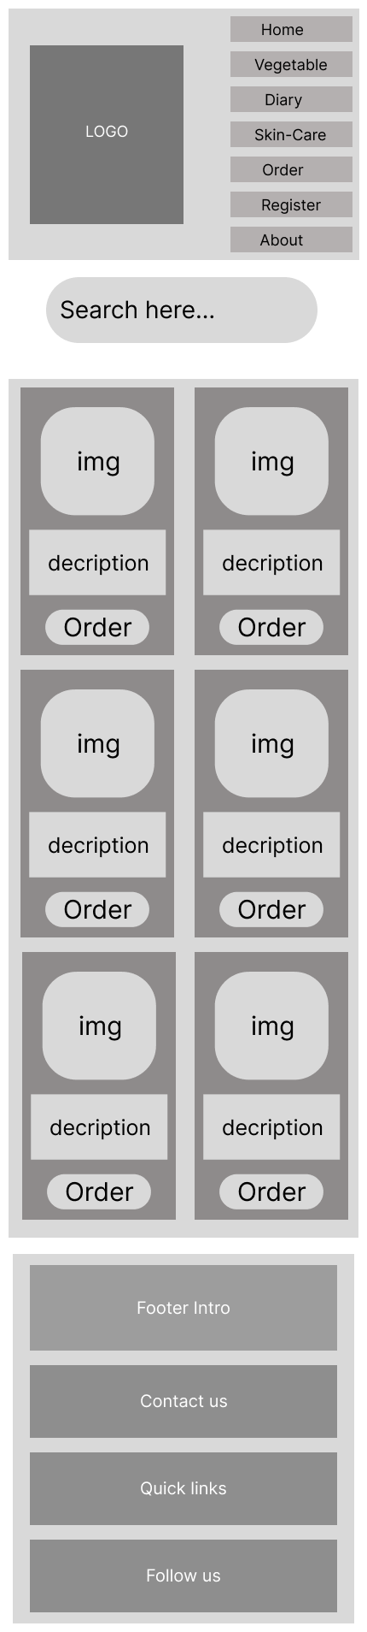

About Us page- Mobile
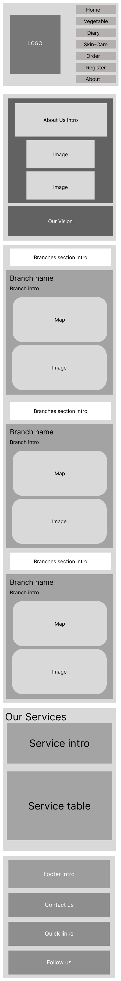
About Us Page - Desktop

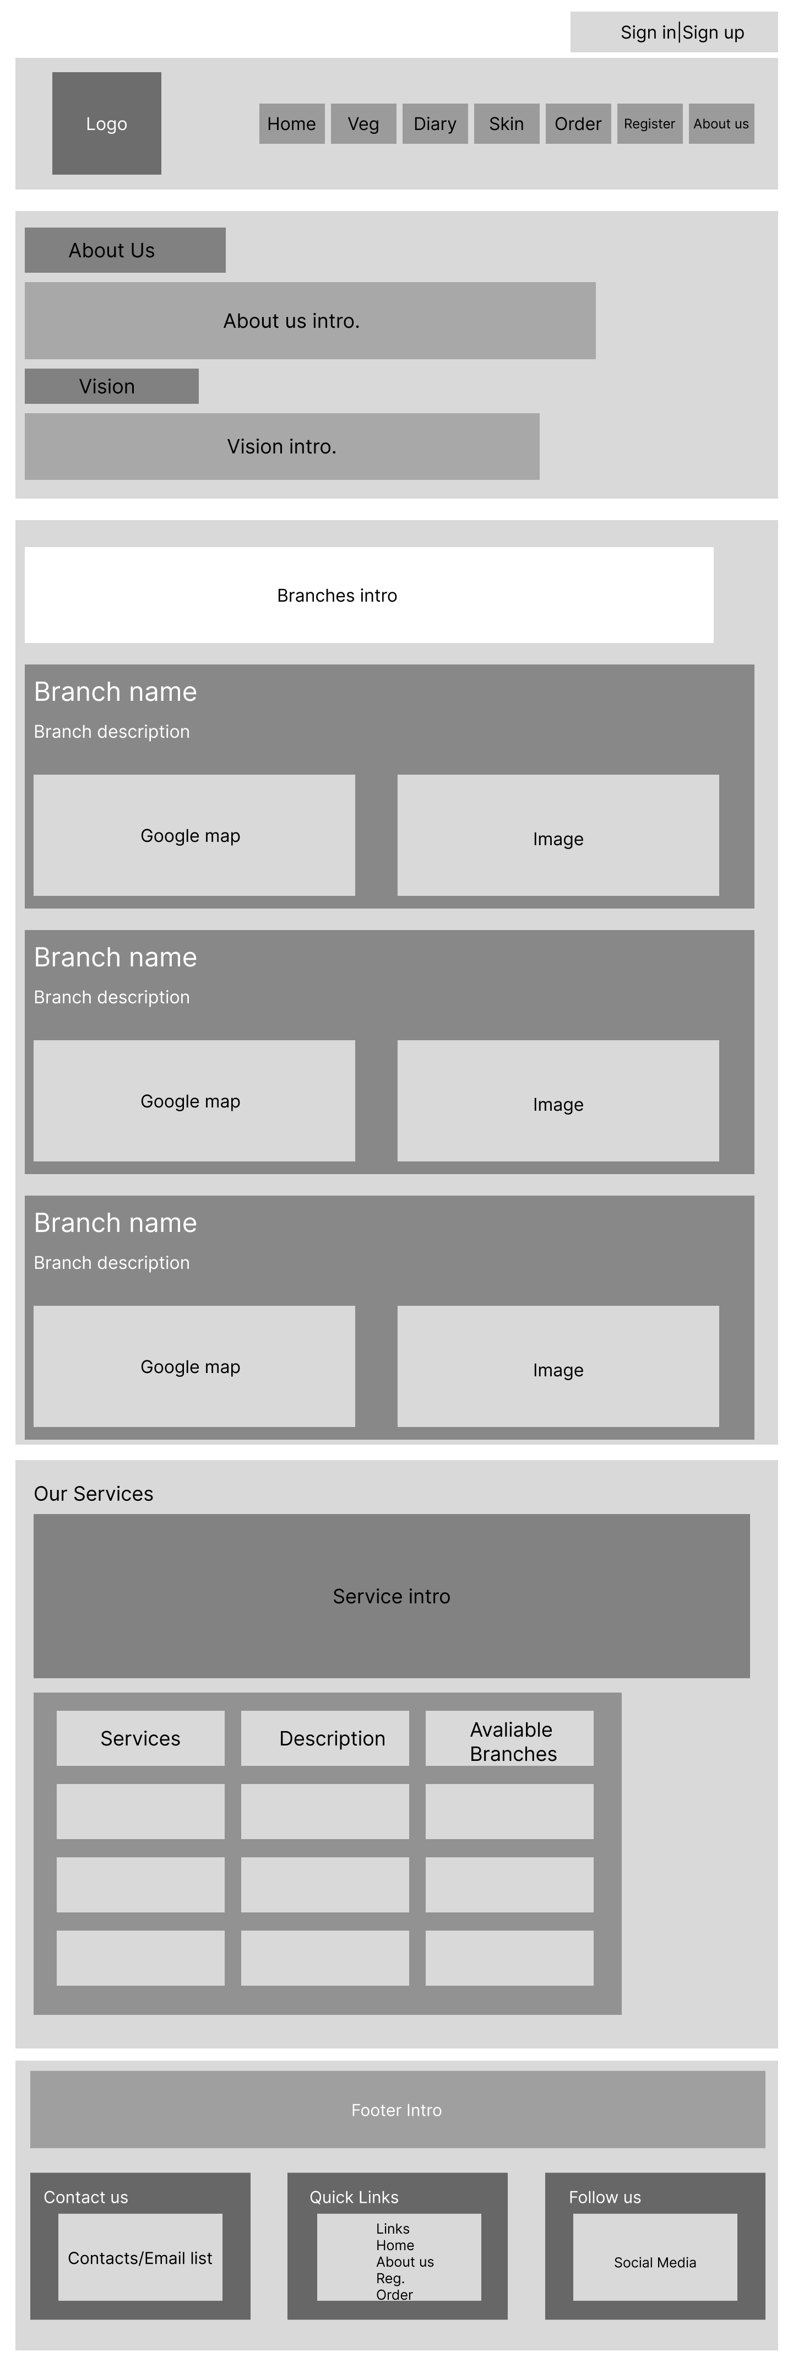

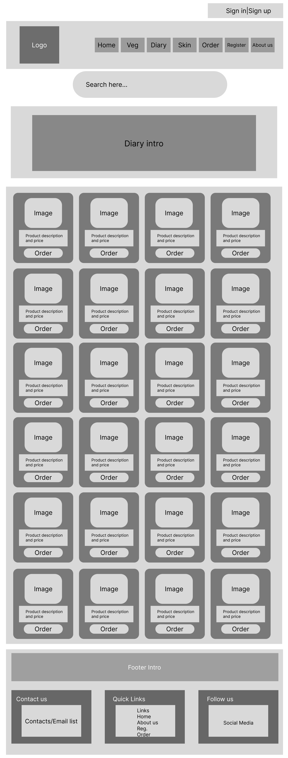
Dairy Page - Desktop

Home Page - Mobile

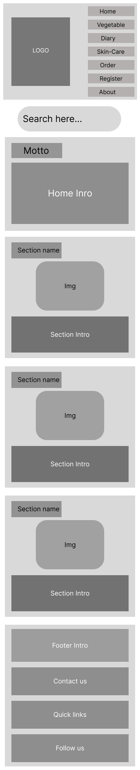

Home Page - Desktop
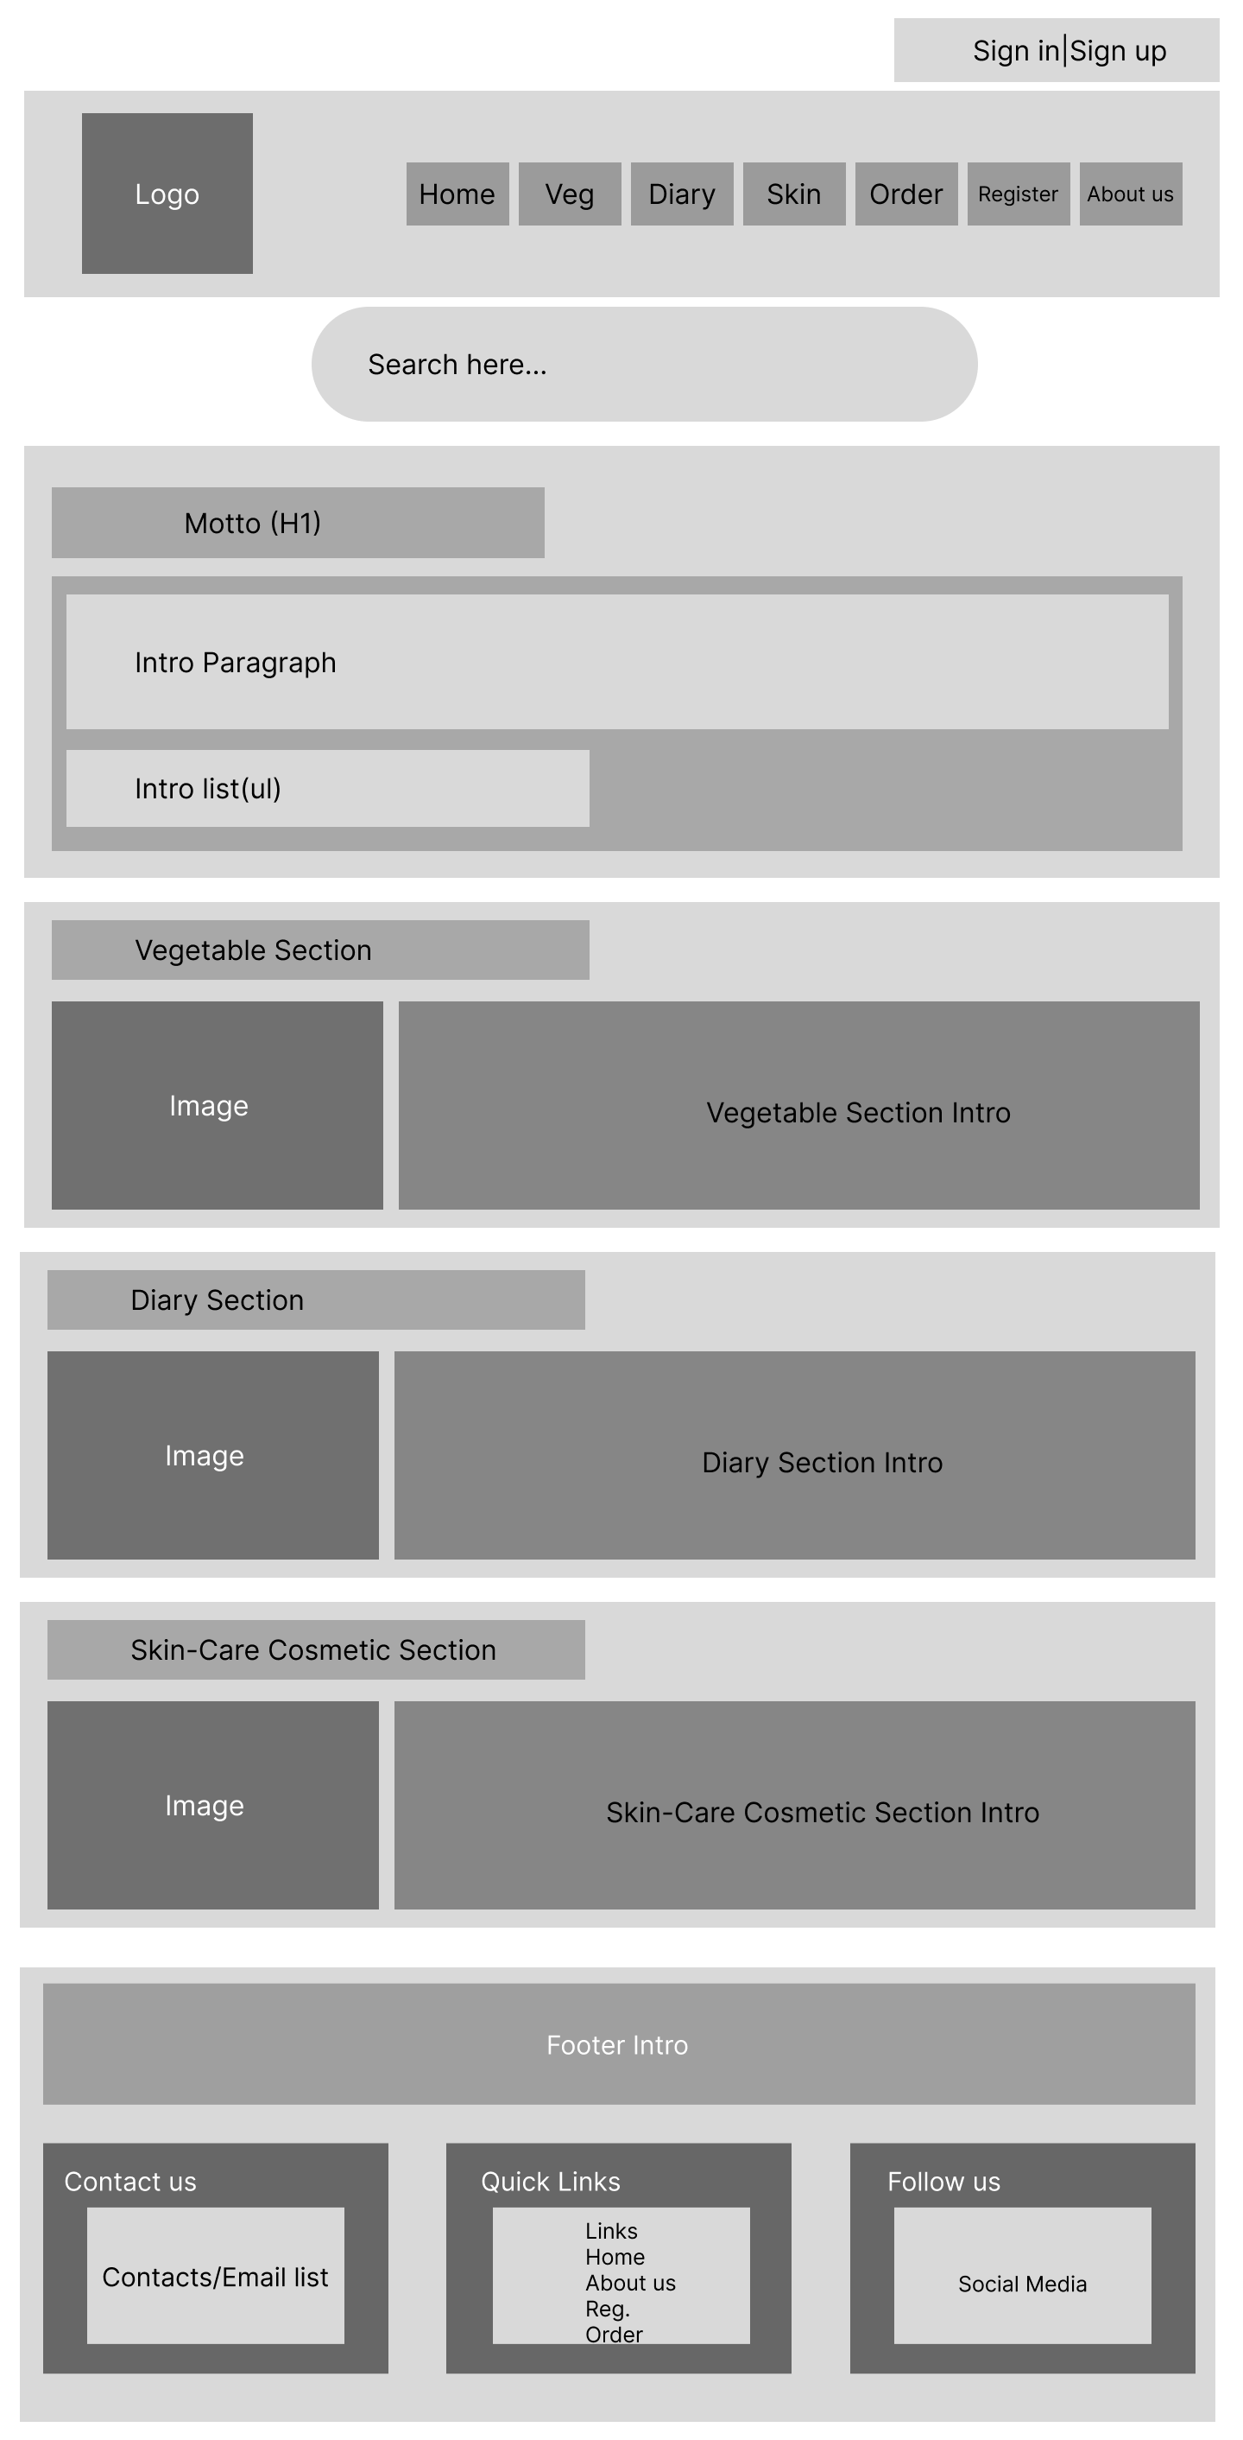

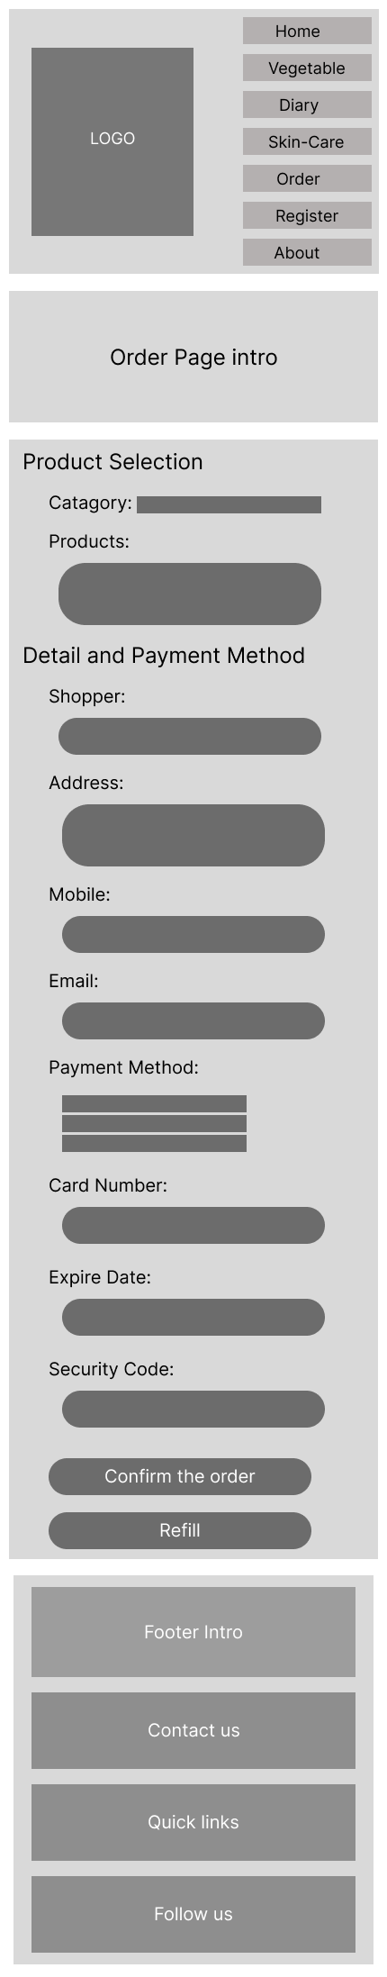
Order Page – Mobile

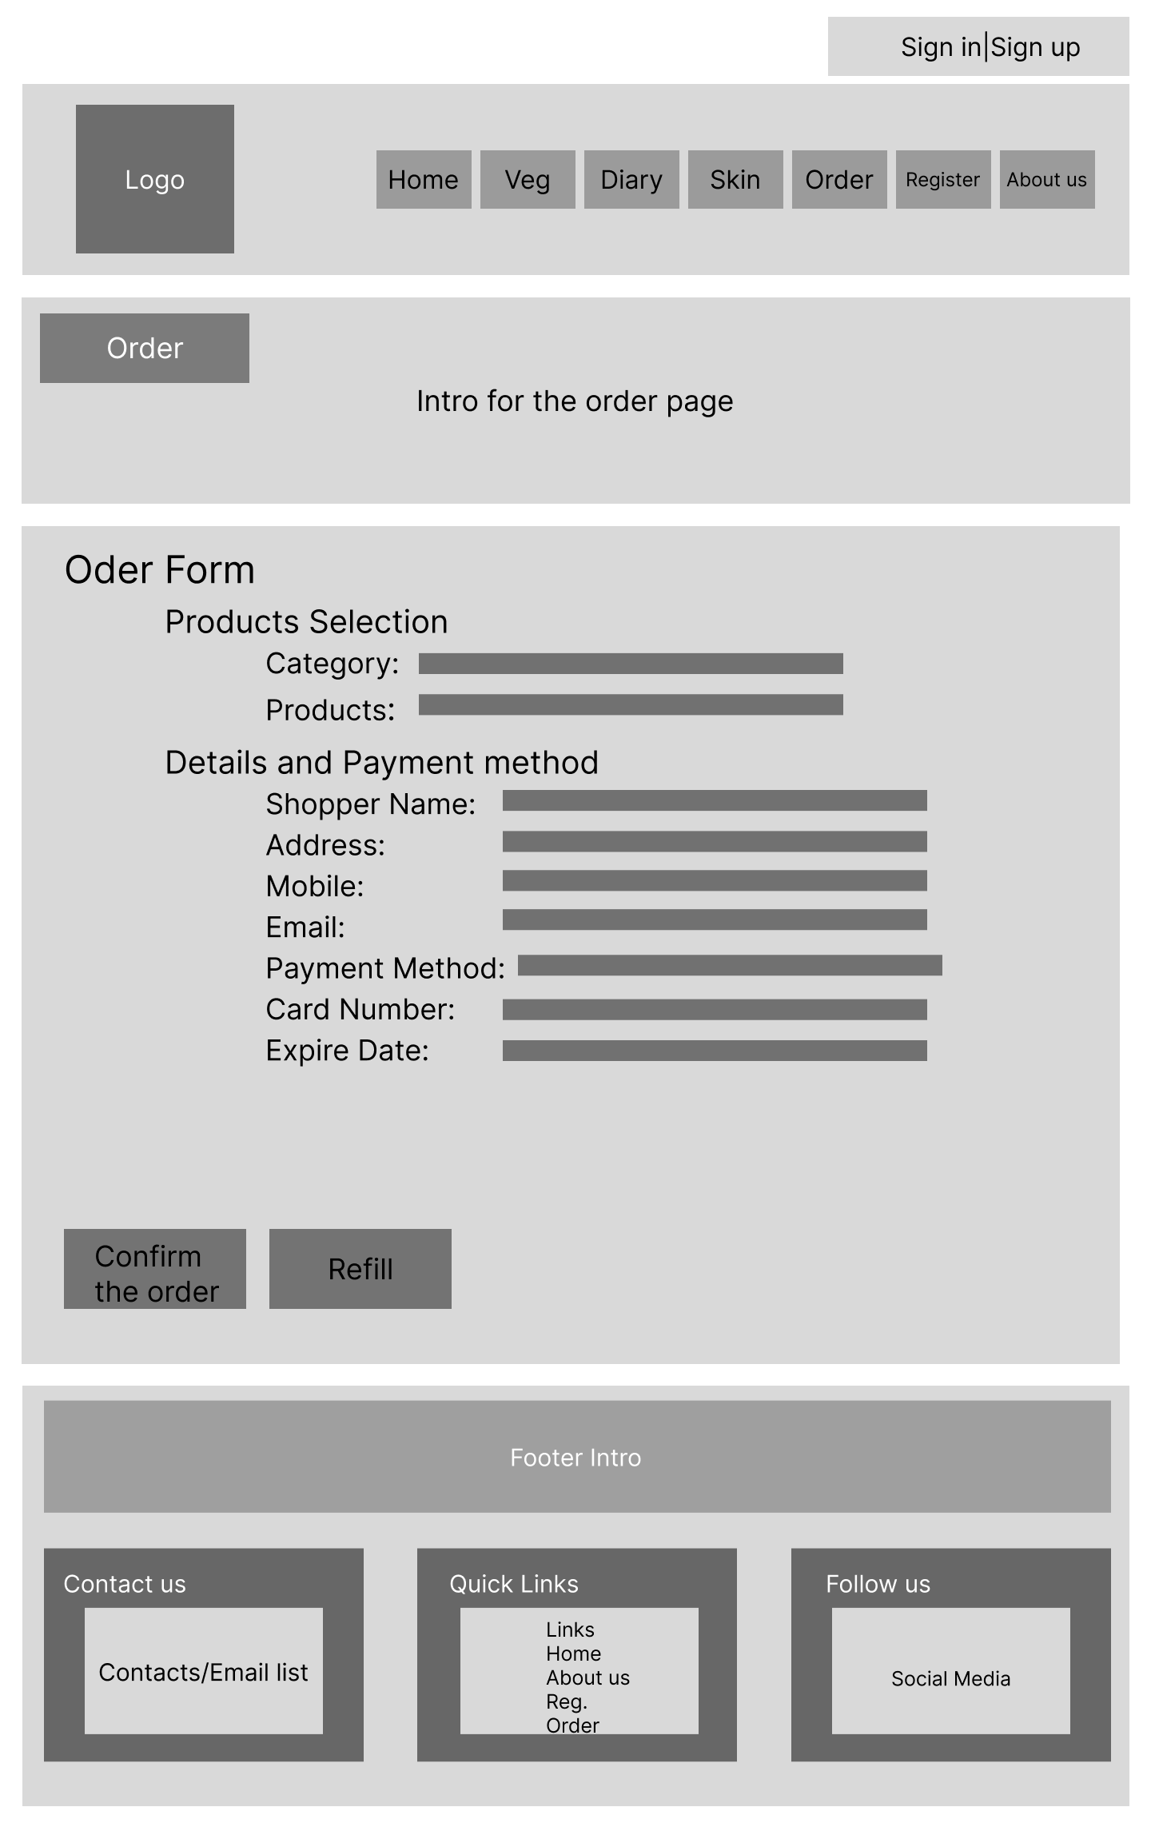
Order Page - Desktop

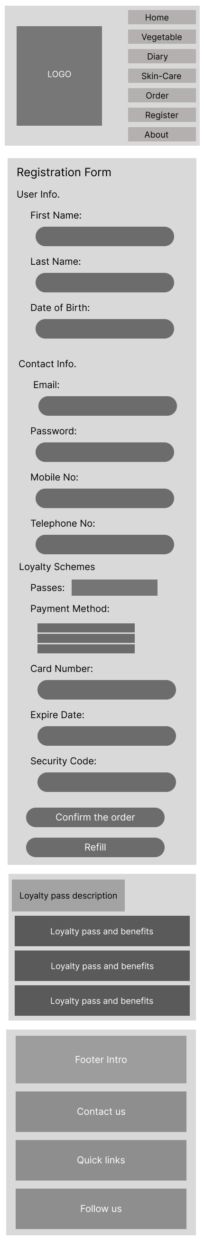
Registration Page – Mobile

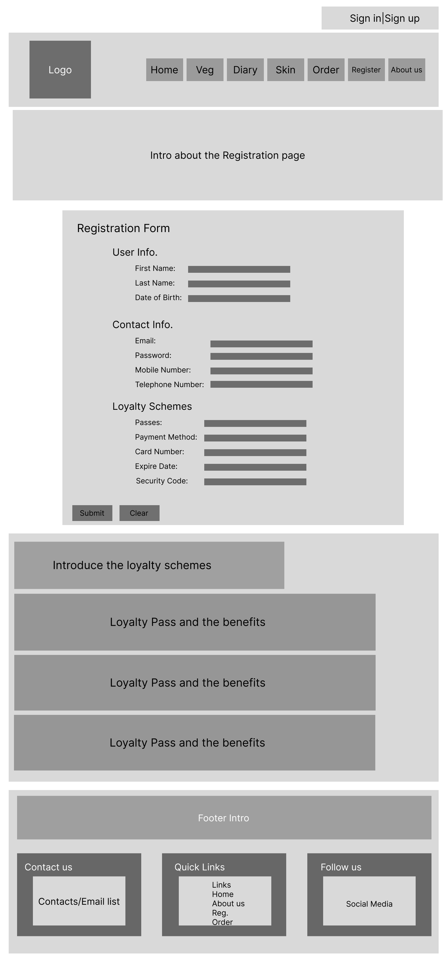
Registration Page - Desktop

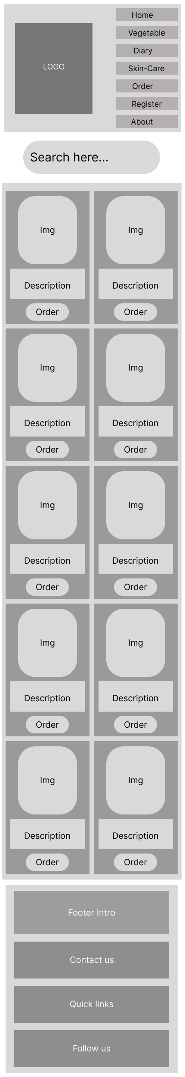
Skin-care Page – Mobile

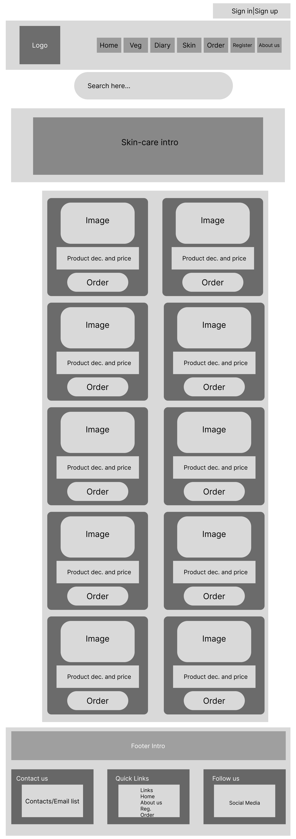
Skin-Care Page - Desktop

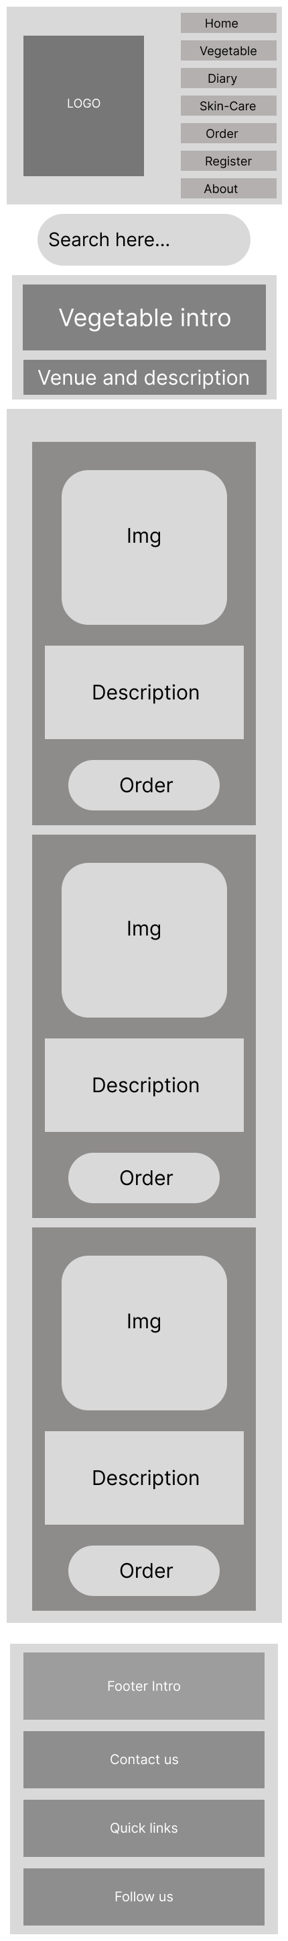
Vegetable Page – Mobile

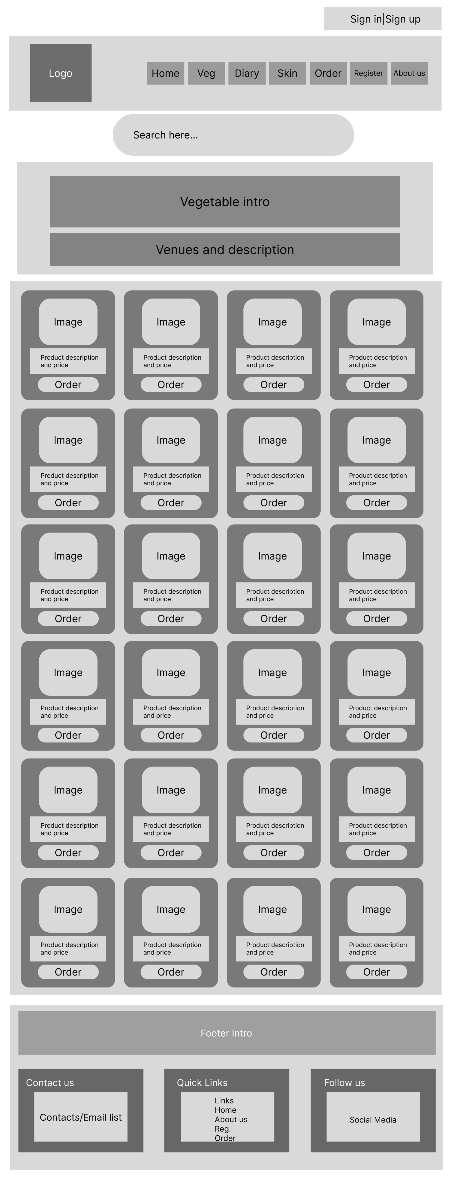
Vegetable Page - Desktop

